**Steps to follow:**

1) Launch the Eclipse IDE and from Help menu, click “**Install New Software**”.

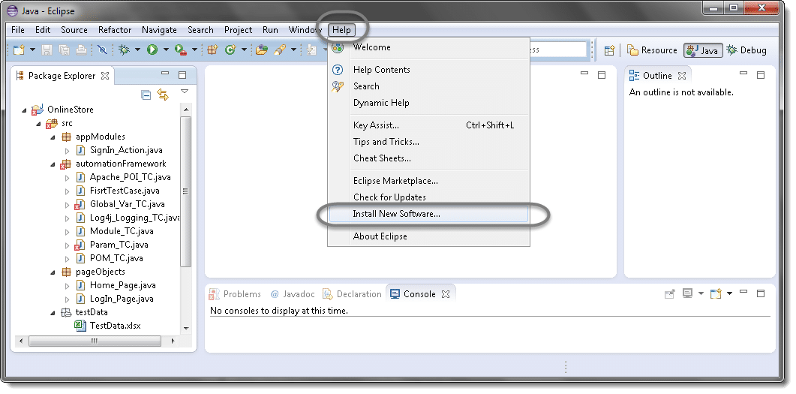

2) You will see a dialog window, click “**Add**” button.

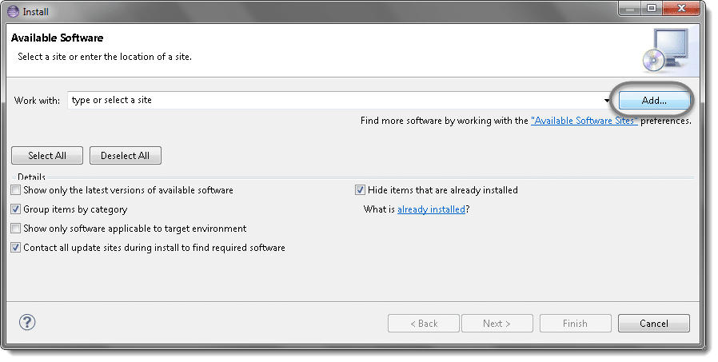

3) Type name as you wish, lets take “**TestNG**” and type “**http://beust.com/eclipse/**” as location. Click OK.

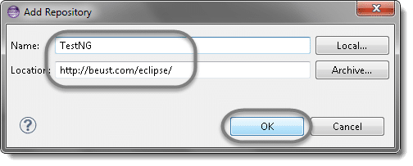

4) You come back to the previous window but this time you must see TestNG option in the available software list. Just Click TestNG and press “**Next**” button.

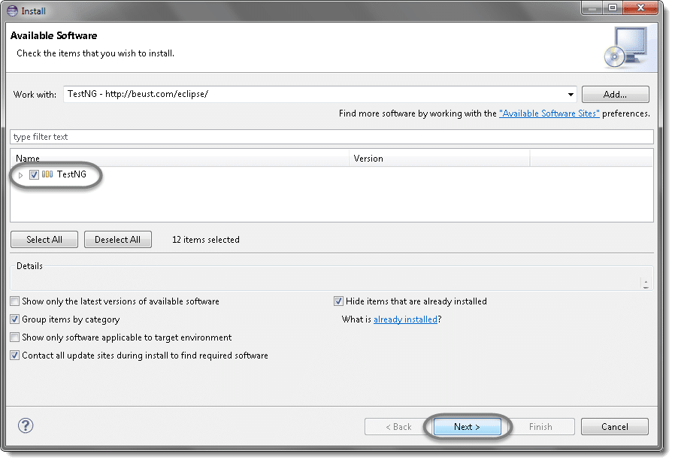

5) Click “**I accept the terms of the license agreement**” then click **Finish**.

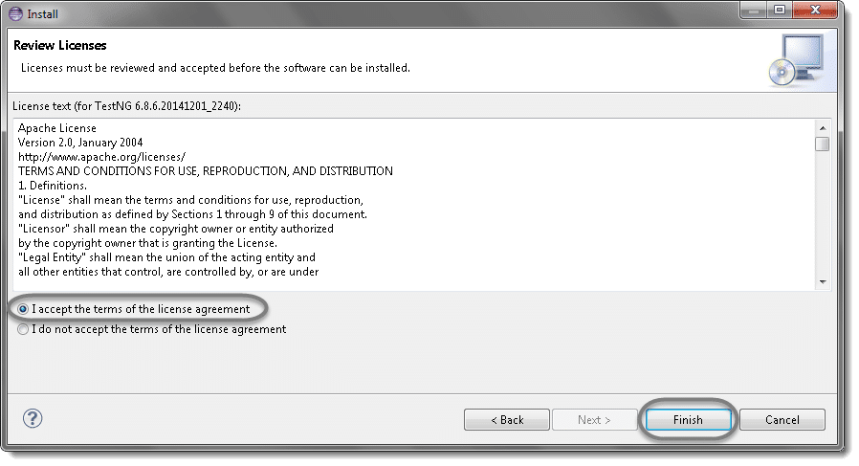

6) You may or may not encounter a Security warning, if in case you do just click **OK**.

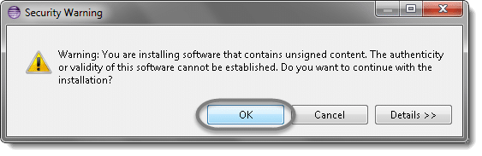

7) Click **Next** again on the succeeding dialog box until it prompts you to Restart the Eclipse.

8) You are all done now, just Click **Yes**.

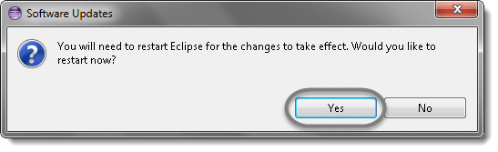

9) Proceed with your workplace.

10) After restart, verify if TestNG was indeed successfully installed. Right click on you project and see if **TestNG**is displayed in the opened menu.

